22.19:

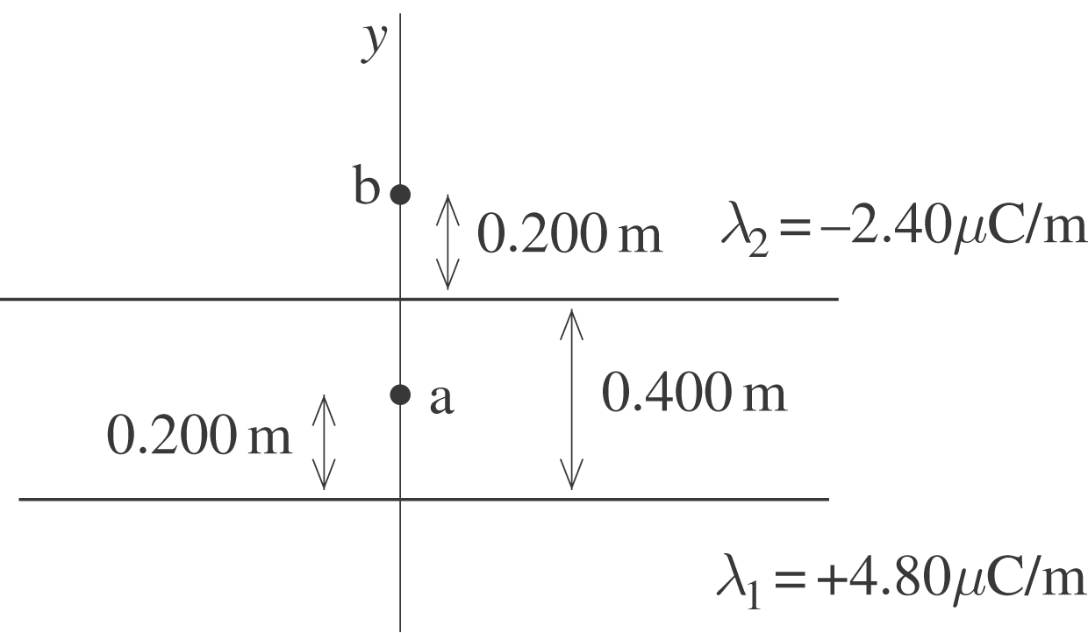

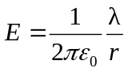

a) At point 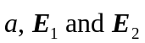 are in the 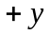-direction (toward negative charge, away from positive charge).
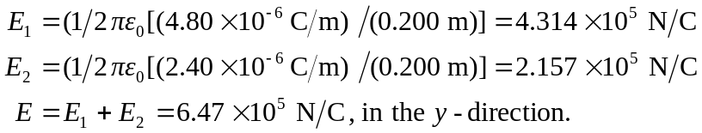
b) At point -direction.
